**P.RAJYALAKSHMI(192011200)**

**USING RAPTOR – DISPLAY POSITION OF NUMBERS**

**FLOWCHART**

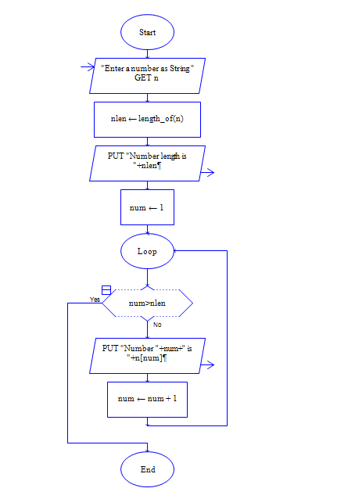

**OUTPUT**

INPUT IS RAJEE12